**ZPHISHER ( instagram traditional page)**

**STEP:1 open kali linux terminal and write cammond git clone –depth=1** [**https://github.com/htr-tech/zphisher.git**](https://github.com/htr-tech/zphisher.git)

**STEP:2 after installation write cammond : cd zphisher**

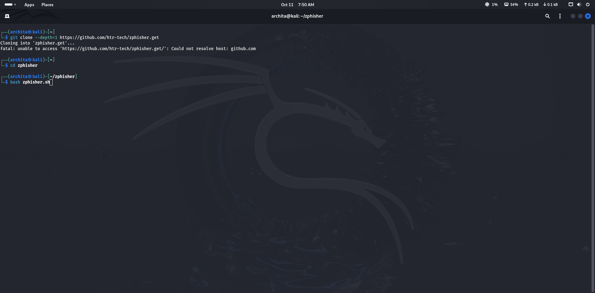

**STEP : 3 then write cammond : bash zphisher.sh**

**Zphisher is open:**



**STEP:4 select the option which you want to make example: 2 (instagram)**

**STEP:5 then select the sub-option of the page Example:1 (traditional)**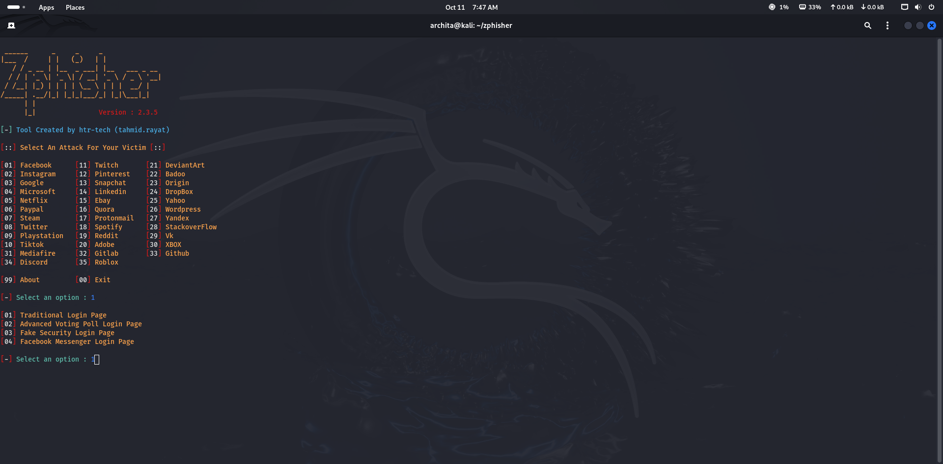

**STEP:6 then select number 2 ( cloudflared) and select “n” to custom part**

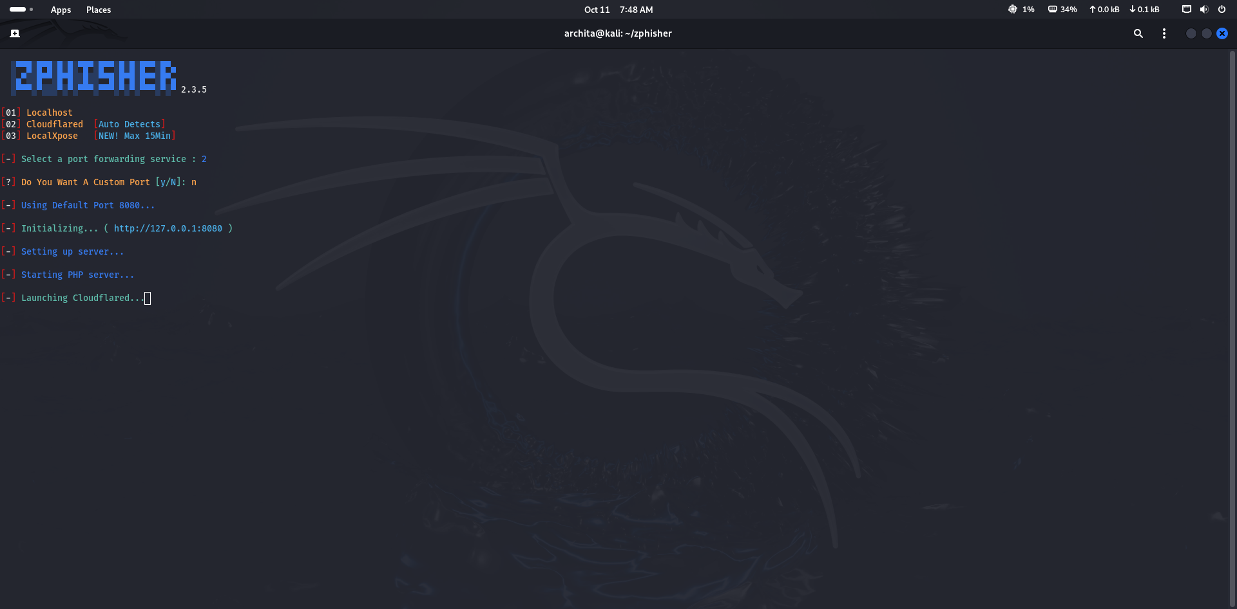

**(after that the url of fake page is generatd)**

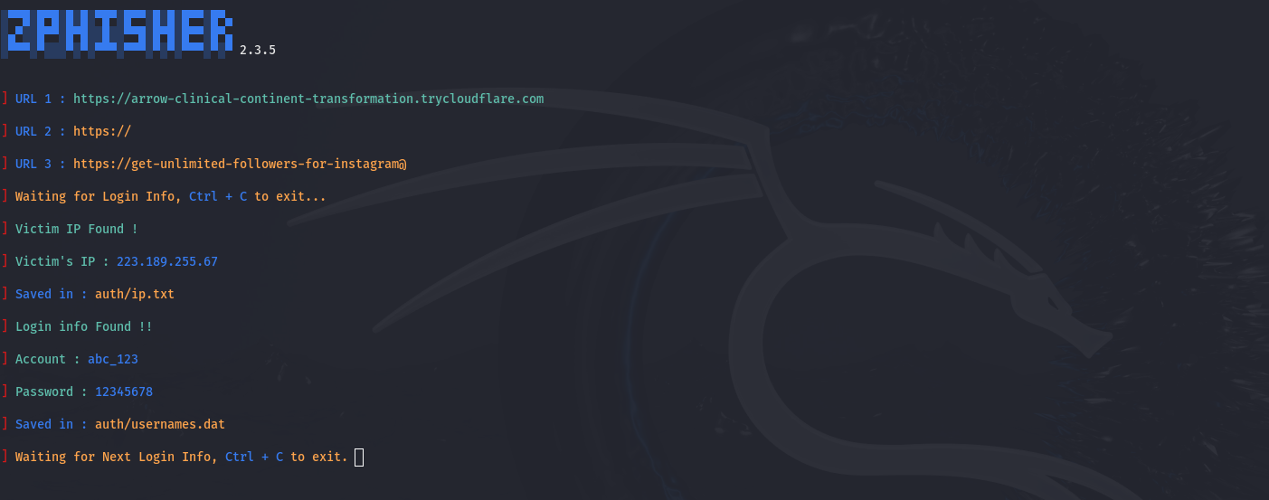

STEP:7 after that copy the url and paste it to brower and fake login is open

* **s**